Implementation Details and Test Cases

Code:

File Structure:
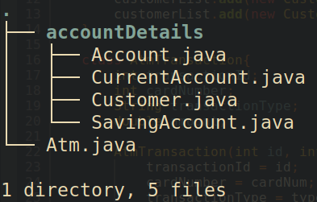

Account:
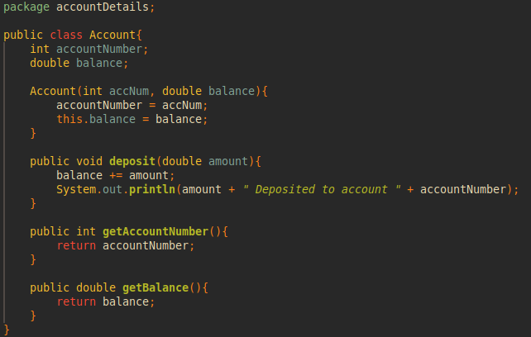

CurrentAccount:
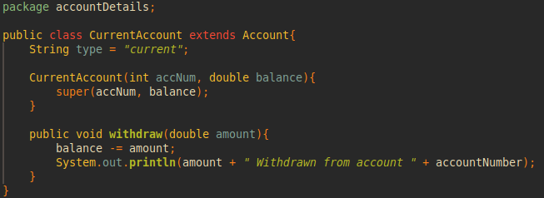

SavingAccount:
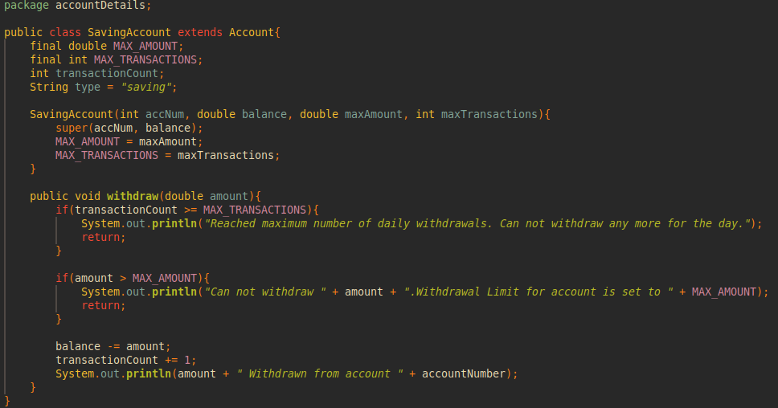

Customer:
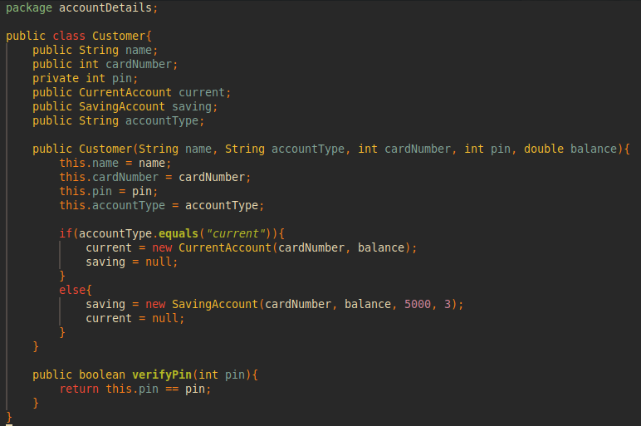

Atm:
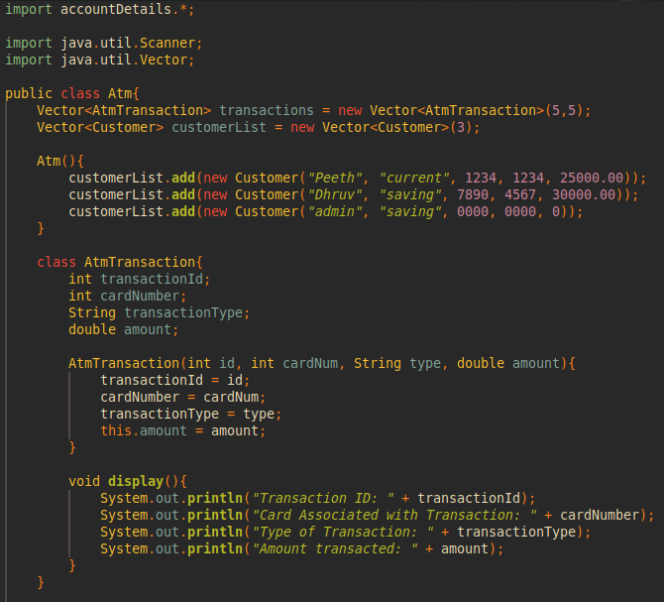
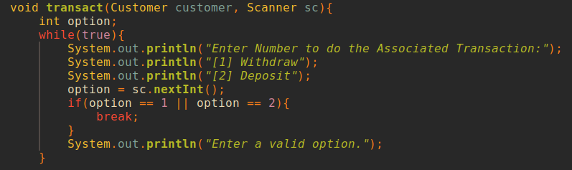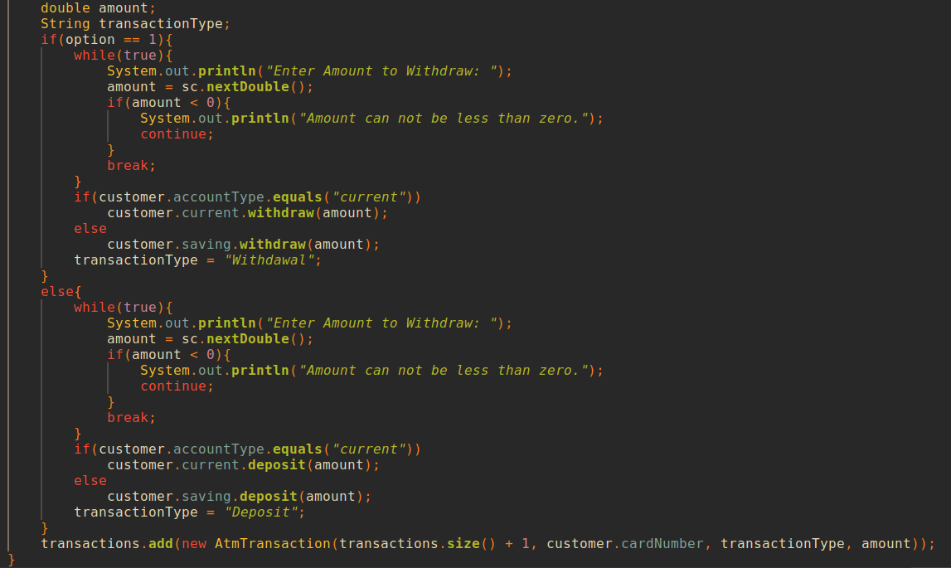
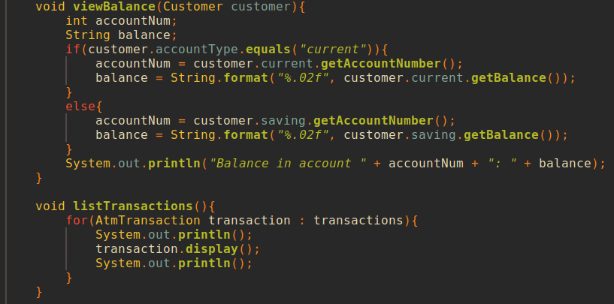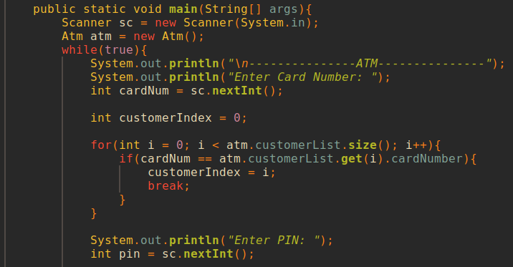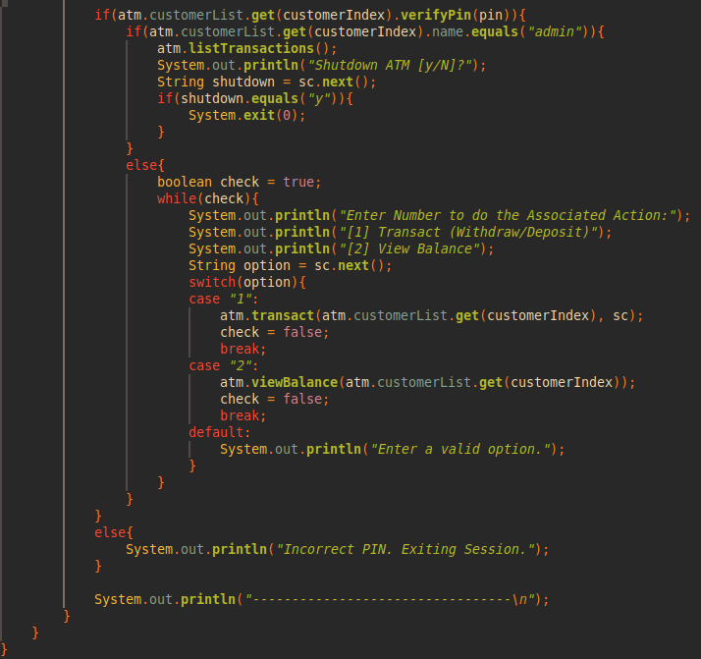

Test cases:
All test cases show that the implementation works as intended

- Able to withdraw any amount from current accounts:
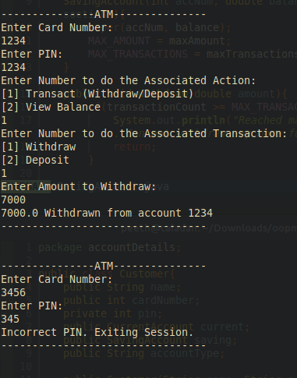

- Entering an incorrect PIN:


- Unable to withdraw over a set limit (5000) from a savings account:
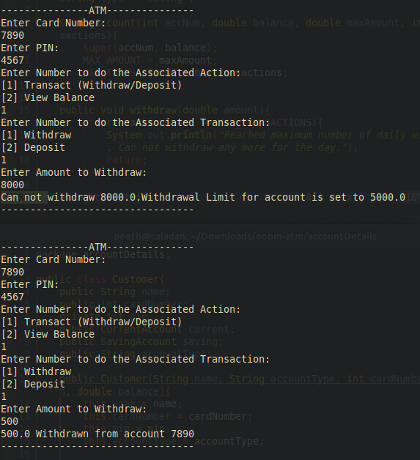

- Unable to withdraw from a saving account more than thrice:


[ 5) Program asks for valid input at each step related to the user deciding which action to take:]
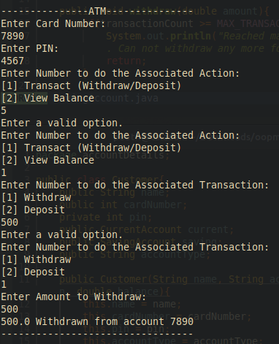
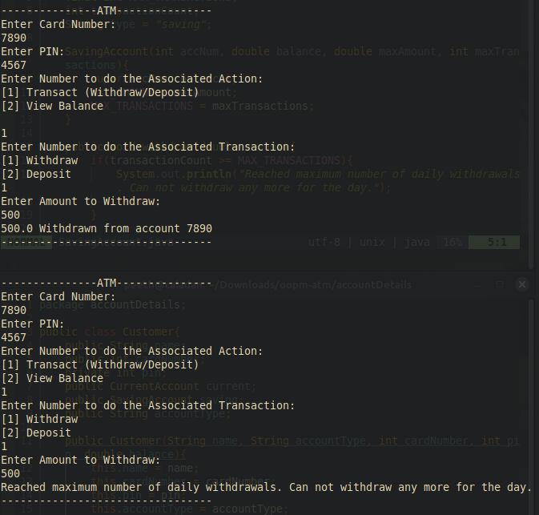
Above is the desired output for Test 4
6) Balance is displayed correctly after the above transactions: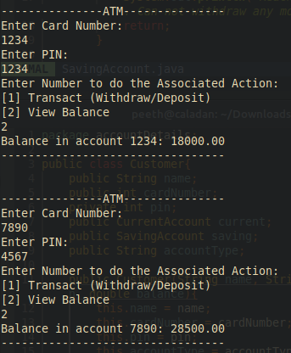

7) Admin gets a record of all transactions at this ATM and an option to shut it down (exit program):
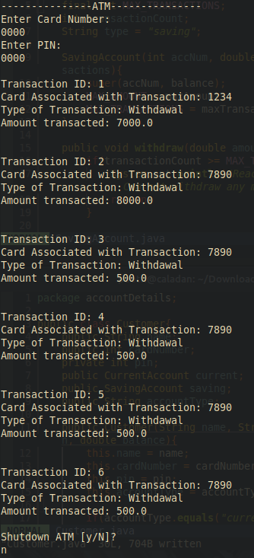

8) If Admin opts to Shutdown the ATM, then the program ends:
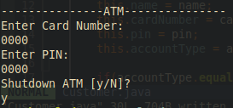

9) Balance also update properly after deposits (25000 + 3000 = 28000):
